



Distinguished Speaker Series
Presented by the San Fernando Valley Unit
Join us via Zoom for our discussion of

US v Weber
﻿Who Owns Voter Data?

 | 
  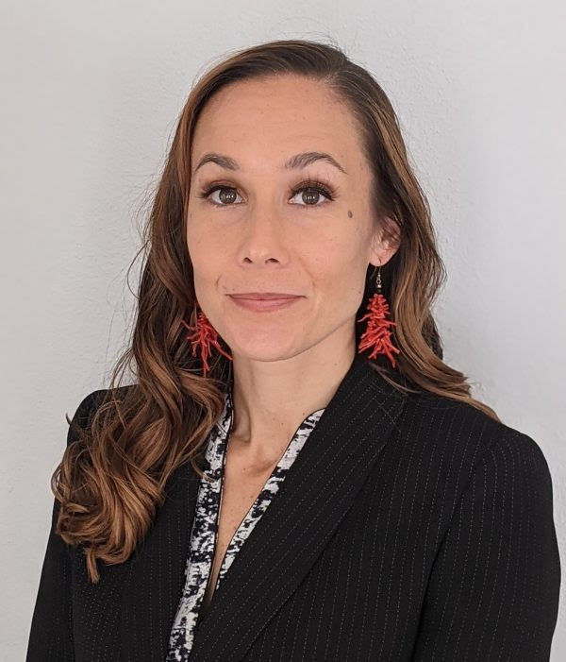

﻿Speaker:
Grayce Zelphin
Senior Staff Attorney
﻿ACLU Northern California

Grayce Zelphin engages in both litigation and policy advocacy focusing on issues promoting racial and economic justice. She is also part of the California statewide Education Equity and Economic Justice groups.
﻿
On Jan. 22, Attorney Zelphin will explain the League's role in the case US v Weber, why this case is important, and the ramifications of Judge Carter's decision. The Judge has stated that he expects his decision to be appealed all the way to the Supreme Court. This is your opportunity to learn about the beginning before you hear the Supreme Court's decision.

Date: Thursday, January 22, 2026, at 12:30pm﻿

REGISTER HERE

